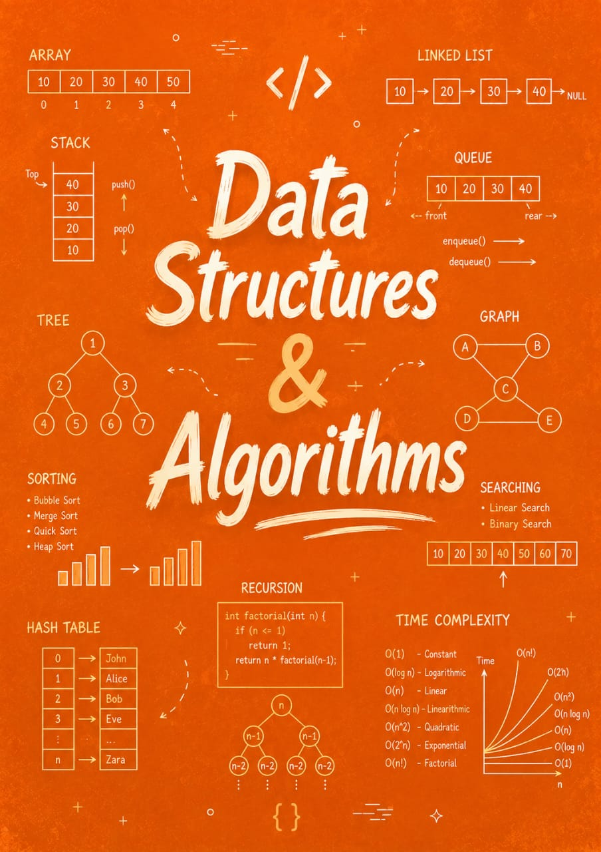

Java Data Structures and Algorithms

By Jawad Jammoul

